lication Design

Number System Conversion Project Report

**Submitted To :**

#### **Name** : Saima Siddique Tashfia

#### **Designation :** Lecturer of uits

#### **Date of Submission :** 09/12/2024

#### **Cours code** : CSE 412

**Course title :** Operating Systems Lab

ion :Date of Submission :

et of Things Lab

ion :Date of Submission :

**Submitted By :**

**Name :** Md Shariful islam sajib sarker (2125051016)

**Name :** Kamrun nahar mitu (2125051019)

**Name :** Kamrul Huda Sattari Saad (2125051041)

**Name :** Md Tajbeer Ahamed Rimon (2125051007)

**Batch** : 50

**Submitted By :**

**Name :** Md Shariful islam sajib sarker (2125051016)

**Name :** Kamrun nahar mitu (2125051019)

**Name :** Kamrul Huda Sattari Saad (2125051041)

**Name :** Md Tajbeer Ahamed Rimon (2125051007)

**Batch** : 50

Table Of Contents

1. Introduction 1

2. Background 1

3. Methodology 2

3.1 Menu Design 2

3.2 Input Validation 2

3.3 Conversion Logic 3

3.4 Error Handling 3

3.5 Custom Base-to-Base Conversion 3

3.6 Looping Mechanism 3

4. Results/Output 3

4.1 Sample Runs 10

5. Conclusion and Future Work 12

5.1 Conclusion 12

5.2 Future Work 12

6. References 13

# Introduction

Number system conversions are a critical aspect of computer science and software development, enabling programmers to work with various numerical representations effectively. This project demonstrates the implementation of a versatile Bash script designed to perform these conversions interactively.

The script features a menu-driven interface where users can select the type of conversion they wish to perform, enter the number, and receive the result instantly. It supports conversions between Binary, Decimal, Octal, and Hexadecimal number systems, and includes a custom option for conversions between any of these bases. The user can also exit the program at any point, ensuring a seamless experience.

By leveraging the capabilities of Bash scripting and built-in Linux tools, this project highlights how command-line scripts can be used to solve practical computational problems efficiently.

# Background

In the realm of computing, number systems such as Binary (Base-2), Decimal (Base-10), Octal (Base-8), and Hexadecimal (Base-16) play a fundamental role in data representation and computation. Conversions between these systems are often required in various scenarios, including:

* Debugging low-level programs.
* Understanding memory addresses.
* Interpreting machine code.

Traditional number system conversion involves manual calculations or the use of specialized tools. However, Bash scripting provides a lightweight, scriptable alternative for performing such conversions directly in the command line, offering the benefits of flexibility, automation, and portability.

This project seeks to implement a robust script that supports these conversions, incorporating validation and error handling to ensure accuracy and reliability.

# Methodology

The Bash script was designed and implemented with the following key steps:

## Menu Design

A user-friendly menu was created to display the available conversion options. The menu includes:

* **Decimal to Binary**
* **Decimal to Octal**
* **Decimal to Hexadecimal**
* **Binary to Decimal**
* **Octal to Decimal**
* **Hexadecimal to Decimal**
* **Custom Conversion (Any Base to Any Base)**
* **Exit**

The menu is displayed in a loop, allowing the user to perform multiple conversions without restarting the program.

## Input Validation

A function was implemented to validate input numbers based on their base. For example:

* Binary numbers must contain only 0 and 1.
* Octal numbers must contain digits from 0 to 7.
* Hexadecimal numbers can contain digits 0-9 and letters A-F.

## Conversion Logic

The script performs conversions in two steps:

1. Convert the input number to its Decimal equivalent.
2. Convert the Decimal number to the desired output base.

This approach ensures that any base-to-base conversion is possible using intermediate Decimal representation.

## Error Handling

The script checks for invalid inputs and provides appropriate error messages, prompting the user to try again. This ensures a smooth user experience and prevents incorrect results.

## Custom Base-to-Base Conversion

The custom conversion option allows users to specify any input and output base (from Binary, Octal, Decimal, or Hexadecimal) and convert between them. This flexibility makes the script highly versatile.

## Looping Mechanism

The main program loop ensures that the menu is displayed repeatedly until the user selects the "Exit" option, enabling continuous usage without restarting the program.

# Results/Output

The script was tested extensively with various inputs, and the results were accurate for all supported conversions. Below is the complete code:

|  |
| --- |
| #!/bin/bash  display_menu() {  echo "Number System Conversion Tool"  echo "1. Decimal to Binary"  echo "2. Decimal to Octal"  echo "3. Decimal to Hexadecimal"  echo "4. Binary to Decimal"  echo "5. Octal to Decimal"  echo "6. Hexadecimal to Decimal"  echo "7. Custom Conversion (Any to Any)"  echo "8. Exit"  echo -n "Choose an option: "  }  is_valid_number() {  local number=$1  local base=$2  case $base in  2) [[ $number =~ ^[01]+$ ]] ;;  8) [[ $number =~ ^[0-7]+$ ]] ;;  10) [[ $number =~ ^[0-9]+$ ]] ;;  16) [[ $number =~ ^[0-9A-Fa-f]+$ ]] ;;  *) return 1 ;; # Invalid base  esac  }  convert_from_decimal() {  local decimal=$1  local base=$2  local result=""  local digits="0123456789ABCDEF"  while [ "$decimal" -gt 0 ]; do  remainder=$((decimal % base))  result="${digits:remainder:1}$result"  decimal=$((decimal / base))  done  echo "${result:-0}" # Return 0 if result is empty  }  convert_to_decimal() {  local number=$1  local base=$2  local length=${#number}  local decimal=0  local digits="0123456789ABCDEF"  for (( i=0; i<length; i++ )); do  char=${number:i:1}  value=$(expr index "$digits" "${char^^}") # Convert to uppercase for Hex  value=$((value - 1)) # `expr index` is 1-based  decimal=$((decimal * base + value))  done  echo "$decimal"  }  convert_base_to_base() {  local input_base=$1  local output_base=$2  local number=$3  if ! is_valid_number "$number" "$input_base"; then  echo "Invalid number '$number' for base $input_base. Please try again."  return 1  fi  decimal=$(convert_to_decimal "$number" "$input_base")  result=$(convert_from_decimal "$decimal" "$output_base")  echo "$result"  }  process_conversion() {  case $1 in  1)  echo -n "Enter a Decimal number: "  read decimal  if is_valid_number "$decimal" 10; then  echo "Binary: $(convert_from_decimal "$decimal" 2)"  else  echo "Invalid Decimal number. Please try again."  fi  ;;  2)  echo -n "Enter a Decimal number: "  read decimal  if is_valid_number "$decimal" 10; then  echo "Octal: $(convert_from_decimal "$decimal" 8)"  else  echo "Invalid Decimal number. Please try again."  fi  ;;  3)  echo -n "Enter a Decimal number: "  read decimal  if is_valid_number "$decimal" 10; then  echo "Hexadecimal: $(convert_from_decimal "$decimal" 16)"  else  echo "Invalid Decimal number. Please try again."  fi  ;;  4)  echo -n "Enter a Binary number: "  read binary  if is_valid_number "$binary" 2; then  echo "Decimal: $(convert_to_decimal "$binary" 2)"  else  echo "Invalid Binary number. Please try again."  fi  ;;  5)  echo -n "Enter an Octal number: "  read octal  if is_valid_number "$octal" 8; then  echo "Decimal: $(convert_to_decimal "$octal" 8)"  else  echo "Invalid Octal number. Please try again."  fi  ;;  6)  echo -n "Enter a Hexadecimal number: "  read hex  if is_valid_number "$hex" 16; then  echo "Decimal: $(convert_to_decimal "$hex" 16)"  else  echo "Invalid Hexadecimal number. Please try again."  fi  ;;  7)  echo -n "Enter the Input Base (2, 8, 10, or 16): "  read input_base  echo -n "Enter the Output Base (2, 8, 10, or 16): "  read output_base  echo -n "Enter the Number to Convert: "  read number  if ! [[ "$input_base" =~ ^(2|8|10|16)$ ]] || ! [[ "$output_base" =~ ^(2|8|10|16)$ ]]; then  echo "Invalid base(s). Please enter 2, 8, 10, or 16."  else  result=$(convert_base_to_base "$input_base" "$output_base" "$number")  if [ $? -ne 0 ]; then  echo "Conversion failed due to invalid input. Please try again."  else  echo "Converted Number: $result"  fi  fi  ;;  8)  echo "Exiting..."; exit 0  ;;  *)  echo "Invalid option. Please try again."  ;;  esac  }  while true; do  display_menu  read choice  process_conversion $choice  echo ""  done |

## Sample Runs

**Case 1: Decimal to Binary**

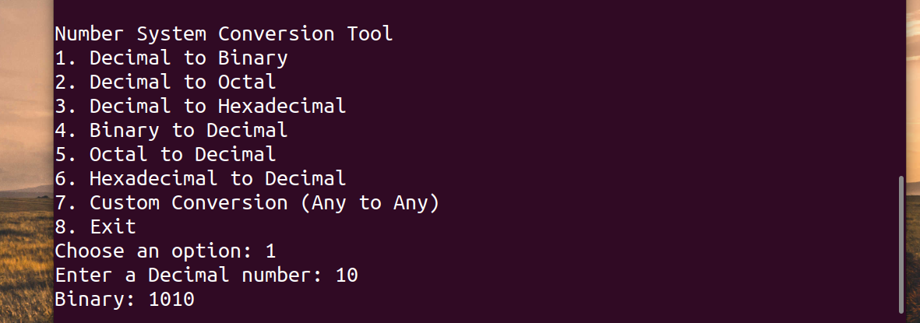

**Input:**

* Decimal Number: 10

**Output:**

* Binary: 1010

**Case 2: Binary to Decimal**

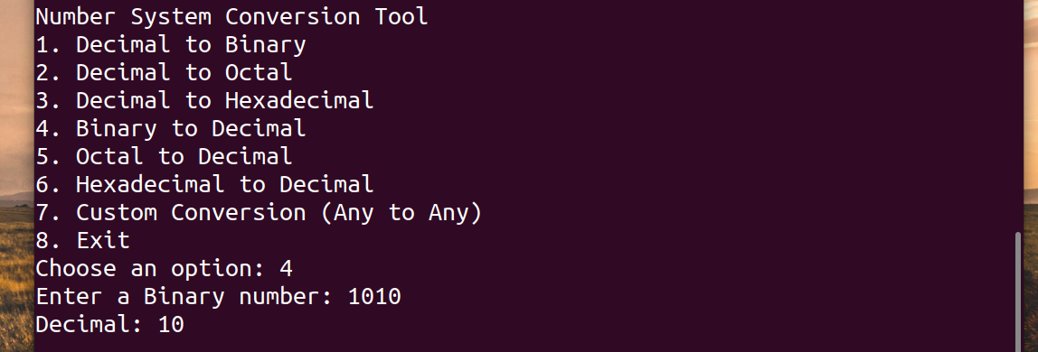

**Input:**

* Binary Number: 1010

**Output:**

* Decimal: 10

**Case 3: Custom Conversion**

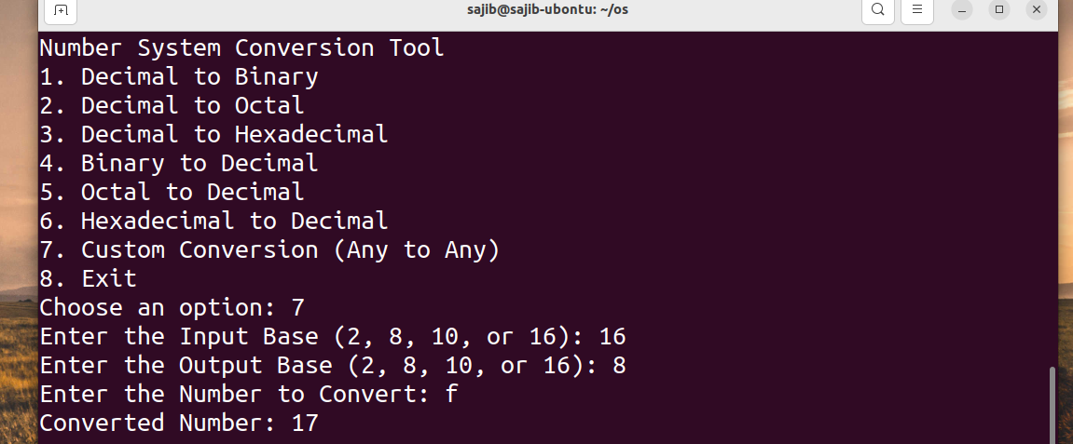

**Input:**

* Input Base: 16 (Hexadecimal)
* Output Base: 8 (Octal)
* Number: F

**Output:**

* Converted Number: 17

**Case 4: Invalid Input**

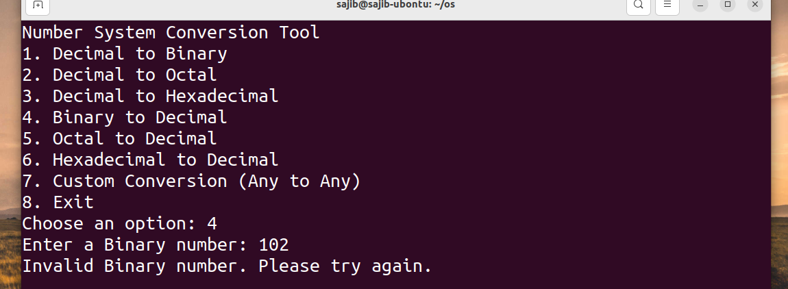

**Input:**

* Binary Number: 102 (Invalid)

**Output:**

* Error: "Invalid Binary number. Please try again."

# Conclusion and Future Work

## Conclusion

This project successfully implemented a Bash script for performing number system conversions, offering a user-friendly interface and robust functionality. The script is efficient and reliable, capable of handling a wide range of conversions with proper validation and error handling.

Key learnings from this project include:

* Mastery of conditional statements (case) and looping constructs in Bash.
* Use of arithmetic and string manipulation techniques for numerical conversions.
* Implementation of input validation to ensure program correctness.

## Future Work

To enhance the script further, the following improvements can be done:

1. **Batch Processing**: Allow the script to process multiple conversions from a file or input list.
2. **Enhanced UI**: Integrate color-coded outputs and animations to improve user experience.
3. **Extended Number Systems**: Support for additional bases, such as Base-3 or Base-7.
4. **Web Integration**: Develop a web interface for the script to make it accessible from browsers.

# References

1. **GNU Bash Manual**: https://www.gnu.org/software/bash/manual/bash.html
2. **Linux Command Documentation**: https://linux.die.net/man/
3. Classroom Notes and Course Materials